**RU Parking**

**ANDROID-BASED APPLICATION FOR SUGGESTING PARKING SPACES**

<http://code.google.com/p/ruparking/>

**Prototype report**

**Project Members:**

**Cyrus Gerami**

**Ashwin Revo**

**Shweta Sagari**

**Samson Sequeira**

**Vrajesh Vyas**

1. Project Hosting

A project repository for RU Parking has been setup on Google Code.

Here is the link to it:

**<http://code.google.com/p/ruparking/source/checkout>**

A read-only copy of the code can be checked out using

**svn checkout http://ruparking.googlecode.com/svn/trunk/ parking-read-only**

We are using Subclipse to upload code to our repository. Subclipse is an Eclipse Team Provider plug-in providing support for Subversion within the Eclipse IDE.

All the team members have actively used the repository and checked in the code. Below is a snapshot of the log:

1. Updated Object Design

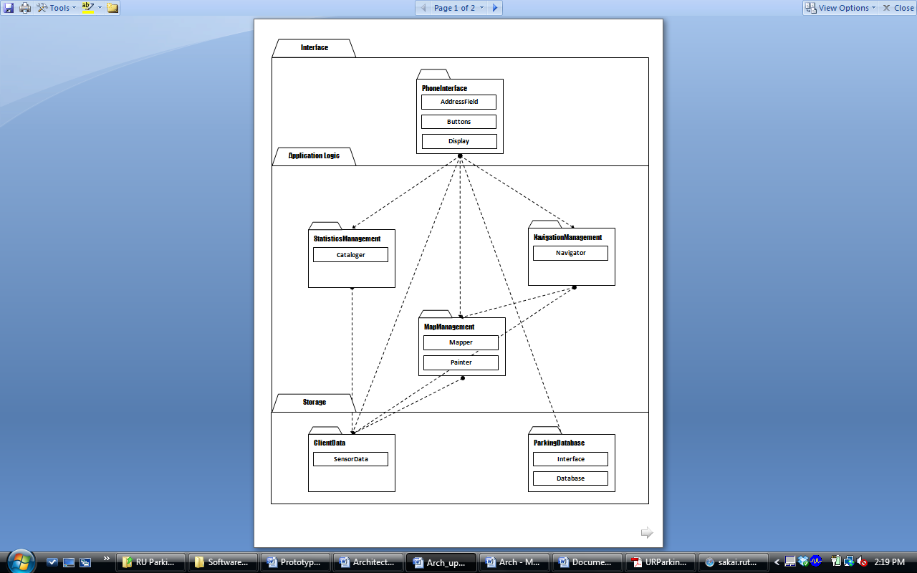The figure below shows the subsystem decomposition of RU Parking.

*Figure 2-1: Subsystem decomposition of RU Parking*

We have not changed our subsystem decomposition to match our 1st prototype. The reason for this is we will be changing our source code to match this decomposition in the final implementation. The prototype is different from the figure because we had to get our application running with the portion of the code that we had written.